|  |  |  |
| --- | --- | --- |
| Year 12 Physics – Lab Validation Assessment  Current Balance – The Motor Effect | | |
|  | | |
| **Name:** | **Teacher:** | **Score /20** |
| **Comment:** | | |



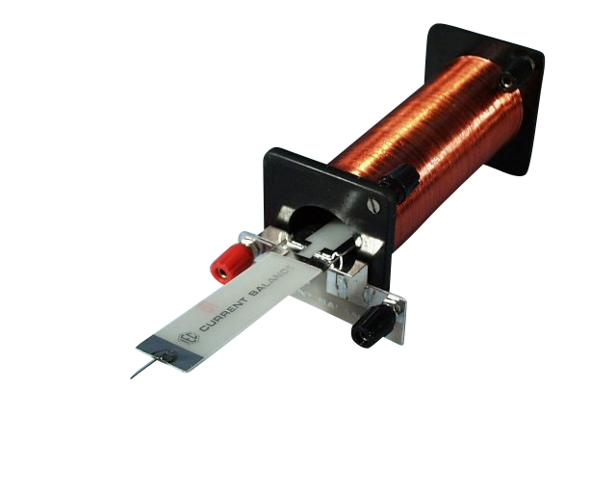

A pair of students are planning an investigation to accurately determine the flux density that exists in the single solenoid when running at 5A.

They know that a good investigation should use a series of measurements, so they vary the mass of nichrome wire at the end of the balance and then measure the amount of current (through the balance loop) that is required to achieve equilibrium with the mass.

To vary the mass they cut the nichrome wire into 2cm lengths and added one another 2cm length after each measurement.

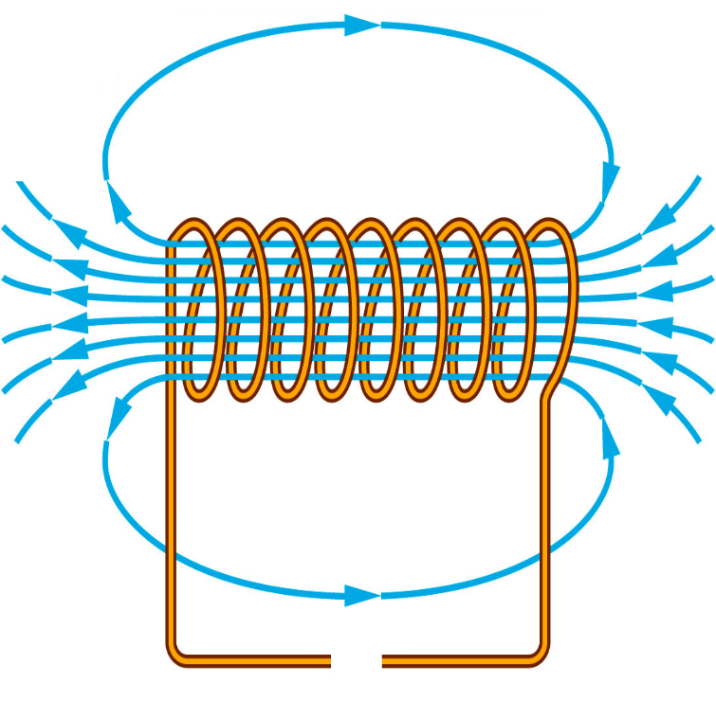

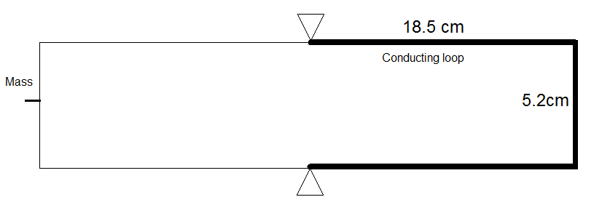***Diagrams -*** *Top down views of the conducting / balance loop and solenoid respectively are shown below. (just before the balance loop is moved to the right into the* solenoid.

Using the information presented in the BOTH diagrams:

1. Draw in the current direction required in the conducting loop to produce a force that could balance the mass at the other end.
2. Correctly draw in the current direction required in the solenoid circuit to produce the field shown.
3. Draw in an appropriate symbol for the DC power supply to match your current direction.

**[3 Marks]**

**Results**

|  |  |
| --- | --- |
| Mass of Nichrome Wire (1 metre length) | 1.75g |
| Length of Balance / Conductor | See diagram |

**Current in loop required to Balance the Mass. (Blank column provided for processing)**

|  |  |  |  |  |
| --- | --- | --- | --- | --- |
| **Number of 2 cm wire pieces** | **Current in Balance (A)** | **Current In Solenoid (A)** | **Mass (kg)** | **Weight Force (N)** |
| 1 | 0.650 | 5.00 | **0.350 x10-4** | **0.000343** |
| 2 | 1.250 | 5.00 | **0.700 x10-4** | **0.000686** |
| 3 | 2.055 | 5.00 | **1.050 x10-4** | **0.001029** |
| 4 | 2.595 | 5.00 | **1.400 x10-4** | **0.001372** |
| 5 | 3.105 | 5.00 | **1.750 x10-4** | **0.001715** |
| 6 | 3.990 | 5.00 | **2.100 x10-4** | **0.002058** |
| 7 | 4.440 | 5.00 | **2.450 x10-4** | **0.002401** |
| 8 | 5.350 | 5.00 | **2.800 x10-4** | **0.002744** |

1. What was the Independent variable in this experiment? **Force / Mass of Wires/ Number of lengths**
2. What was the Dependent Variable? **Current in the Loop**
3. Describe two variables that were controlled.

**Must be specific 🡪 i.e Length of conductor in field, Current in Solenoid.**

**(Do not pay … “Same equipment” Year 12 is the big league. We don’t pay year 8 answers!)**

**[4 Marks]**

1. Process the results to calculate mass and weight force.

**(-1) if answers out by factor of 10’s (-1) for any values completely wrong**

**[2 Marks]**

1. On the next page, plot an appropriate graph that compares the comparing the balancing current required to the weight force added.

**[5 Marks]**

**Current on Y axis, Force on X axis (1)**

**Points plotted correctly and neatly (1)**

**Meaningful Title (1)**

**Ruler and pencil used (1)**

**Axis labels with units (1)**

1. Using an appropriate method, calculate the magnetic flux density being produced in the solenoid. You must CLEARLY demonstrate the logic used in your method to attain full marks.

**LOBF drawn on graph (1)**

**TWO appropriately spaced points on LOBF used to calculate gradient. These points must be labelled (or lines drawn down on graph) and gradient calculated using formulae**

**Y2 – y1 / x2 – x1 actual gradient should be close to 1960 (1)**

**Demonstrates from equation that gradient is equal to 1/lB using.**

**If axes swapped, students should rearrange F and I appropriately to get gradient = LB)**

**y = mx y = mx**

**F = l B I I = F / lB I = 1/lB x F**

**Therefor Gradient = 1/lB (logic must be shown)**

**(1)**

**Remembers to converts cm to m (i.e. length = 5.2cm = 0.052m) (1)**

**Use gradient = 1/lB correctly to calculate B (must show calculation) (1)**

**Calculates result that is close to (including correct units) (1)**

**1960 = 1/lB**

**9.81 x10-3 T for B.**

**[6 Marks]**